P S P S’s
INDIRA INSTITUTE OF PHARMACY
A Report on a “Impact Lecture Series” Session II
Date: 02/07/2022

IIP institute innovation council has successfully completed session 2 of the impact lecture series. The impact lecture series is sponsored by the ministry of educations, AICTE, and the ministry of HRD’s IIC. The complete series was bifurcated into 2 sessions. The first session of the impact lecture series was completed on 18/06/2022. The Second session of the impact lecture series was conducted on 02/07/2022.
The Inauguration of the session was started with the formal introduction of the session by Convener IIC by Mr. Nikul Patel at 9:30 a.m. Further, the principal Dr. Amol B. Khade of the institute expresses the objective of the session. They concluded by expressing thanks to the MoE, AICTE, and IIC for providing the sponsorship for the impact lecture series.
The second session of the series comes with two different topics from two separate guest speakers. The first topic of the session was “Scope of innovation in the Pharmaceutical industry” The first lecture starts at 10:00 a.m. Mr. Sachin Lokapure was the resource person who deliver an excellent session on the above-mentioned topic. Mr. Lokapure sir covers multiple points and lastly compiles them together, and explains how these are correlated. While correlating this Mr. Sachin sir, starts with startup procedure, IPR and patenting, funding, and research grant. How these parameters are useful and can use as a business tool he explains in his session. Furter he simulate his presentation for a better understanding of the topic. At last, he provides some case studies which bring the topic to the next level. At the end of the first lecture, participants' queries were resolved by Mr. Sachin Lokapure sir. The gratitude towards the first eminent speaker was expressed by Mr. Sumeet M. Kharat (IIC President).
The second topic of the session was “Role of incubation center in startup journies” The second lecture starts at 11:30 a.m. Mr. Sachin Kumbhoje was the resource person who deliver an excellent session on the above-mentioned topic. Mr. Sachin Kumbhoje starts his session in an innovative way. The session starts with a formal question-answer session which gives idea to speaker the current knowledge of the participants on the mentioned topic. Further, he explains the basic concept of an incubation center and how it will be beneficial to students and faculty. In his session, he explains the procedure of application of the incubation center and how it works for the benefit of the students. Also, he gives recent examples of some startups which are the results of the incubation center. At the end of the second lecture, participants' queries were resolved by Mr. Sachin Kumbhoje. The gratitude towards the second eminent speaker was expressed by Mr. Sumeet M. Kharat (IIC President)
During the session, Ms. Sanika Narvankar introduces the first eminent speaker, while Ms. Gauri Thatte introduces the second eminent speaker. Overall 176 participants were benefited via this impact lecture series. Finally, the whole session was concluded with a vote of thanks by Ms. Akshata Jadhav.
The session ends formality of feedback on sessions and assessments that have been taken. E-certificates were distributed to the participants on the attendance and assessment criteria.
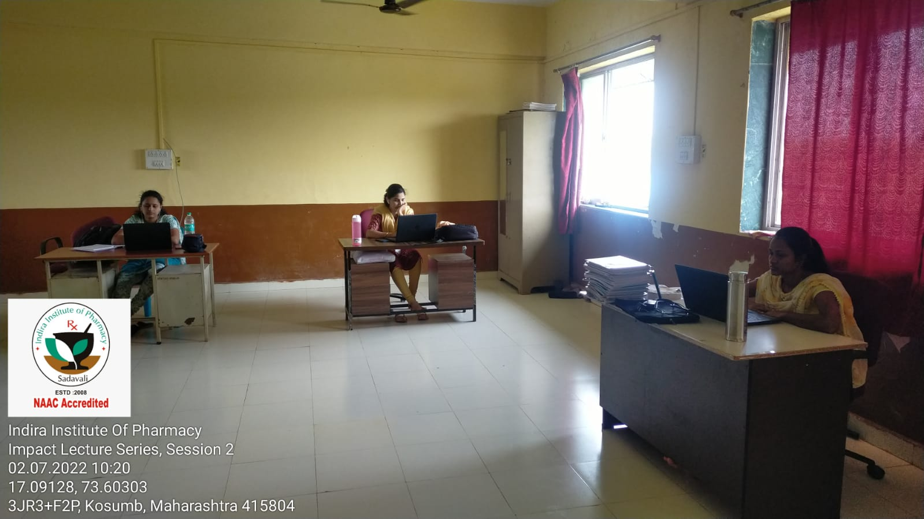
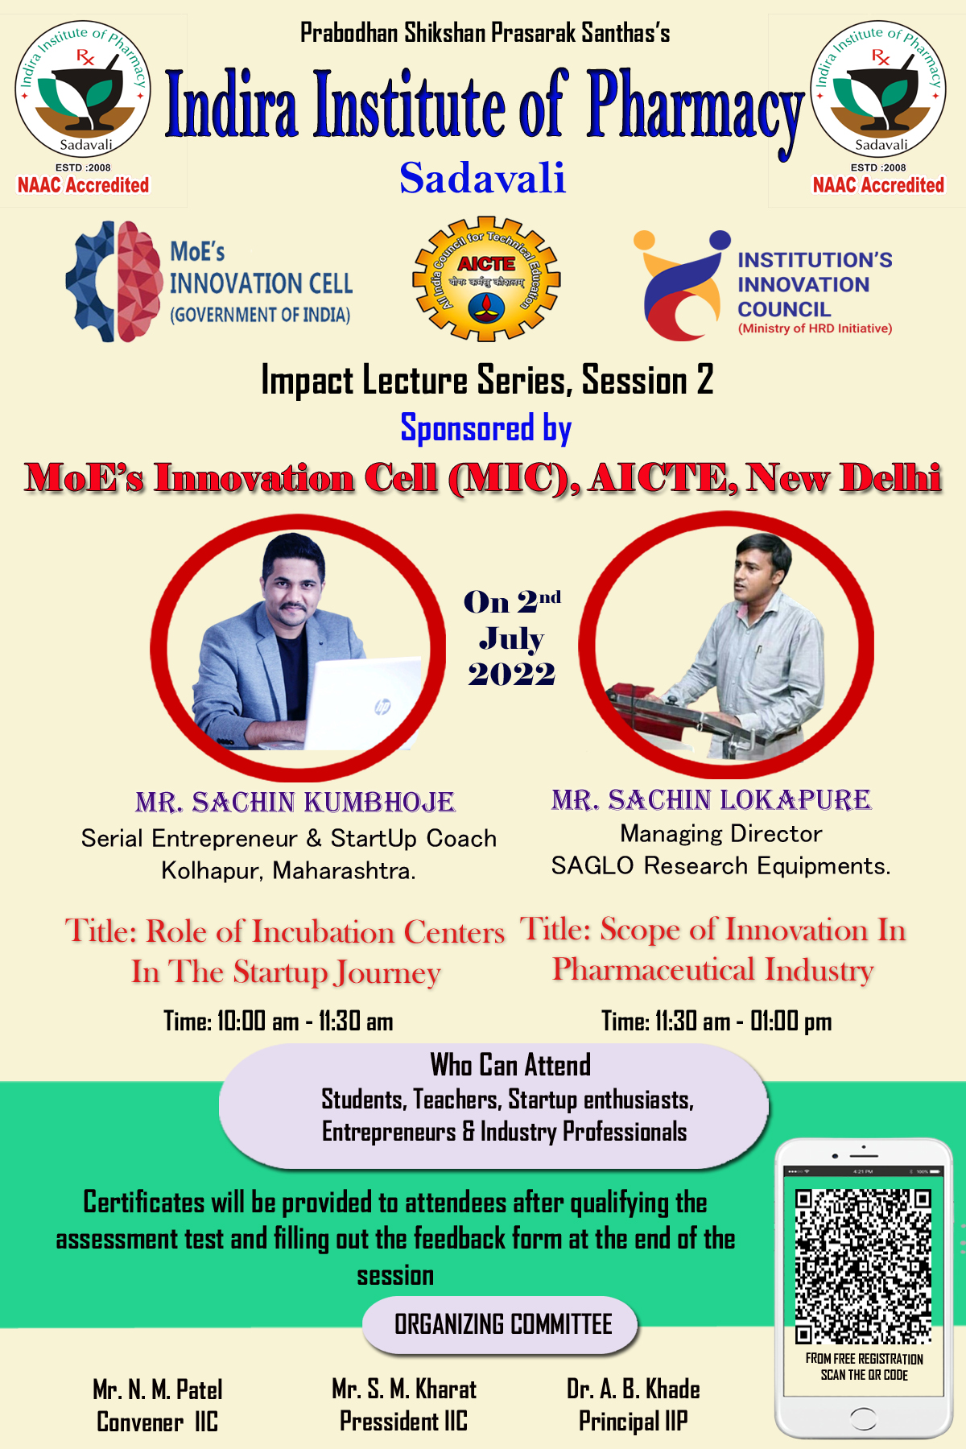
Event Flyer

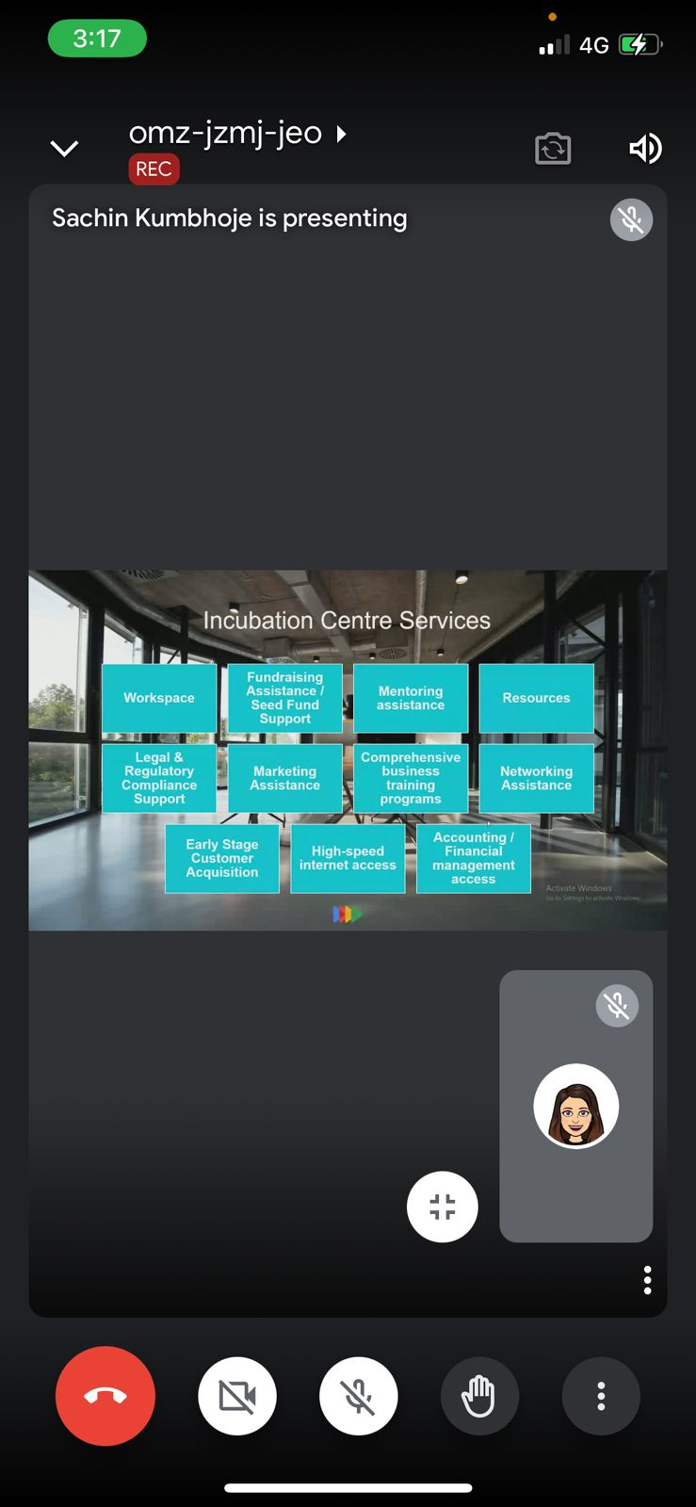
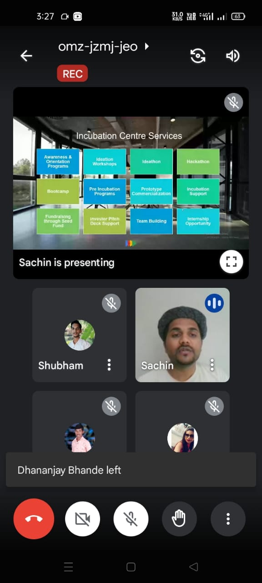
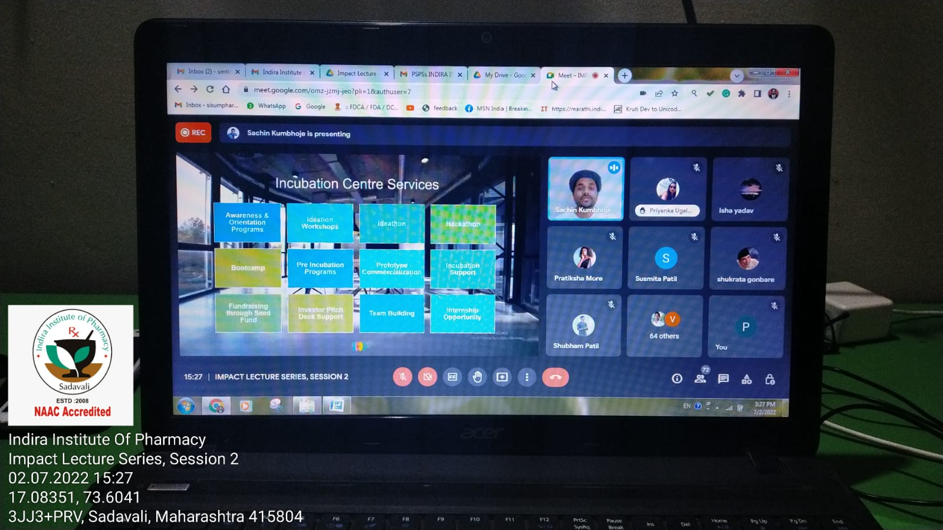
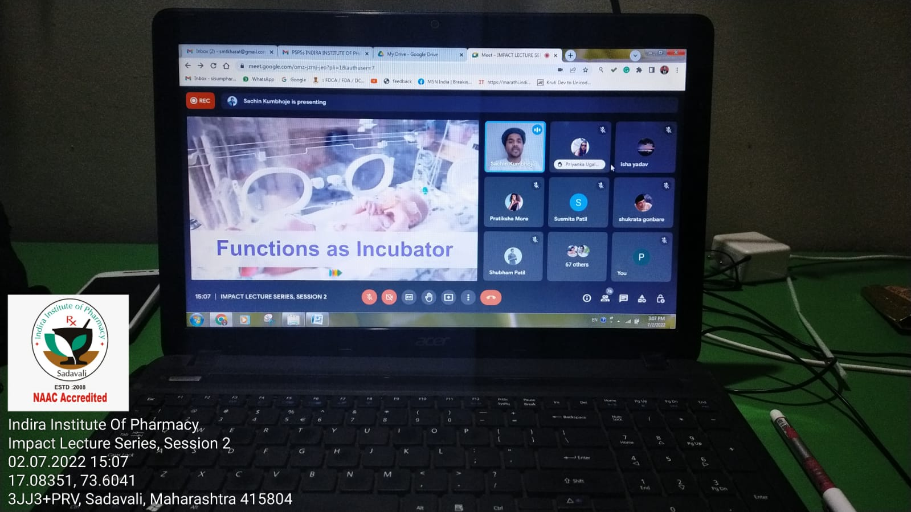
Event Evidence from Participants
Event Photographs

